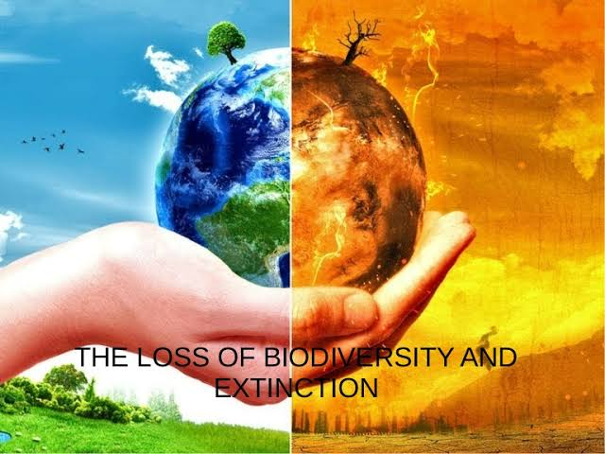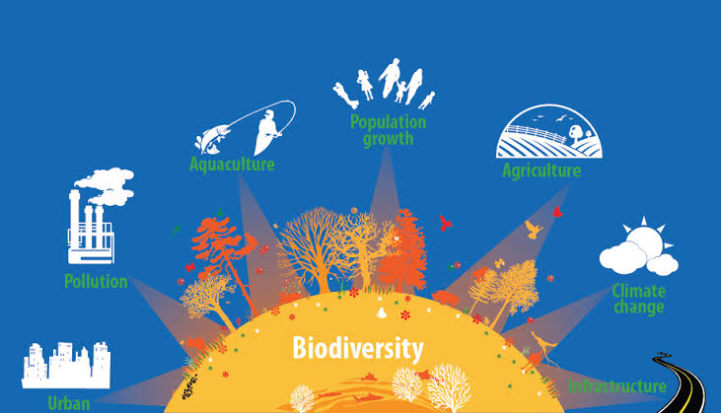

Biodiversity loss, also called loss of biodiversity, a decrease in biodiversity within a species, an ecosystem, a given geographic area, or Earth as a whole.

Biodiversity, or biological diversity, is a term that refers to the number of genes, species, individual organisms within a given species, and biological communities within defined geographic area, ranging from the smallest ecosystem to the global biosphere

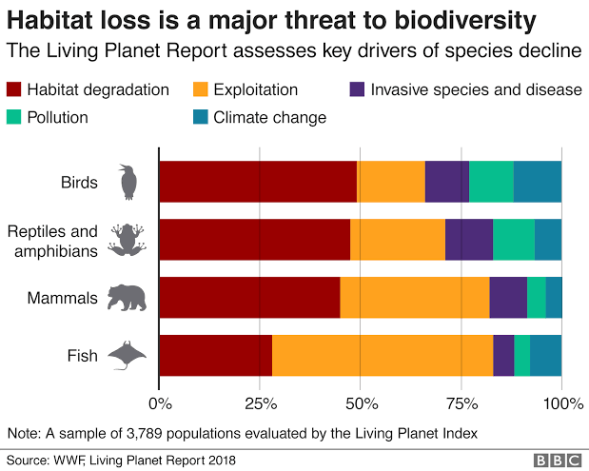

Natural causes :

Biodiversity loss is typically associated with more permanent ecological changes in ecosystems, landscapes, and the global biosphere. Natural ecological disturbances, such as wildfire, floods, and volcanic eruptions, change ecosystems drastically by eliminating local populations of some species and transforming whole biological communities.

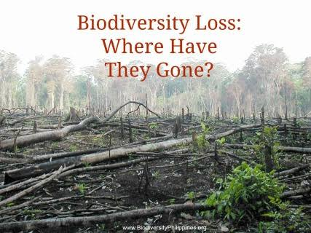Human Causes :

biodiversity losses from disturbances caused by humans tend to be more severe and longer-lasting.

Humans , their crops, and their food animals take up an increasing share of Earth’s land area.

Half of the world’s habitable land (some 51 million square km [19.7 million square miles]) has been converted to agriculture. This massive conversion of forests, wetlands, grasslands, and other terrestrial ecosystems has produced a 60 percent decline in the number of vertebrates worldwide since 1970, with the greatest losses in vertebrate populations occurring in freshwater habitats (83 percent) and in South and Central America (89 percent).

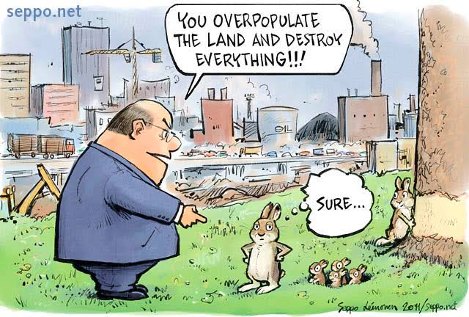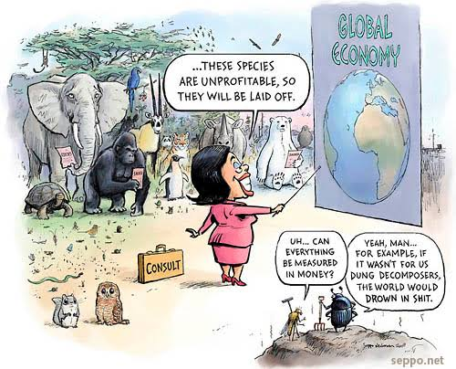 Researchers estimate that the current rate of species loss varies between 100 and 10,000 times the background extinction rate (which is one to five species per year when the entire fossil record is considered).

In addition, a 2019 report by the Intergovernmental Science-Policy Platform on Biodiversity and Ecosystem Services noted that up to one million plant and animal species are facing extinction due to human activities

Effects of Biodiversity Loss

Ecological effects

Spread of diseases

Loss of livelihood for locals

Loss of our recreational space

Society effects

Effect on food production

Economic effects

**Solutions to the Biodiversity Loss Problem**

**Government restrictions and policies :**

Governments are responsible to provide a framework that protects the natural variety of animals and plants. Human greed is endless, thus this will not work without penalizing behavior which threatens a loss in biodiversity.

**Education**:

The education on biodiversity should start quite early, probably in the early school age, so that children are already of this issue quite early and can adapt their behavior into adulthood.

**Protection of species :**

We have to protect many species from hunting or other behavior which threatens their existence. This is especially crucial for species that are already endangered.

For example, elephants are killed just because of their ivory tusks. We have to end this perverse game to avoid a loss of biodiversity.

**Protection of habitats**:

We have to protect the habitats, since if they are destructed, these animals and plants are likely to be endangered from extinction .

**Stop deforestation** :

About 90% of all species on our planet live in the tropical rainforests .Thus, deforestation is a huge problem for the variety of species. If we lose these forests, we will also lose many species which will affect on the whole planet.

**Prevent overhunting and overfishing :**

We should protect animals by setting strict hunting and fishing limits to make sure that populations are able to reproduce and are not becoming endangered of extinction.

**Stop pollution**

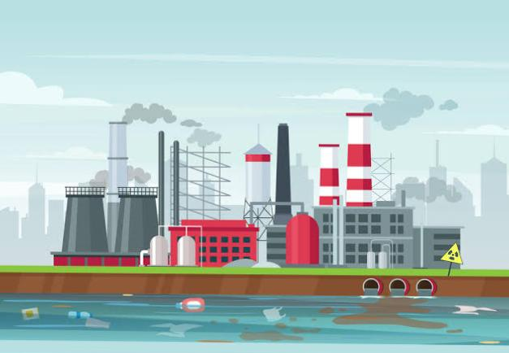

Since through pollution, many ecological parameters are affected in an adverse way, pollution will contribute to a loss in biodiversity since many animals and plants will not be able to adapt to increased pollution properly and eventually go extinct.

**Stop over-exploitation of resources** :

Many of our industries require metals and other materials in order to fulfill their production goals.

However, by extracting these precious resources, the living space of many species will be destroyed. .